DATASCIENCE AND MACHINE LEARNING LAB

CYCLE2

1. Create a three dimensional array specifying float data type and print it.

PROGRAM
import numpy as np

arr = np.array([[[1, 2, 3], [4, 5, 6],[4, 5, 6]], [[1, 2, 3], [4, 5, 6],[4, 5, 6]],[[1, 2, 3], [4, 5, 6],[4, 5, 6]]], dtype='f')
print(arr)

OUTPUT

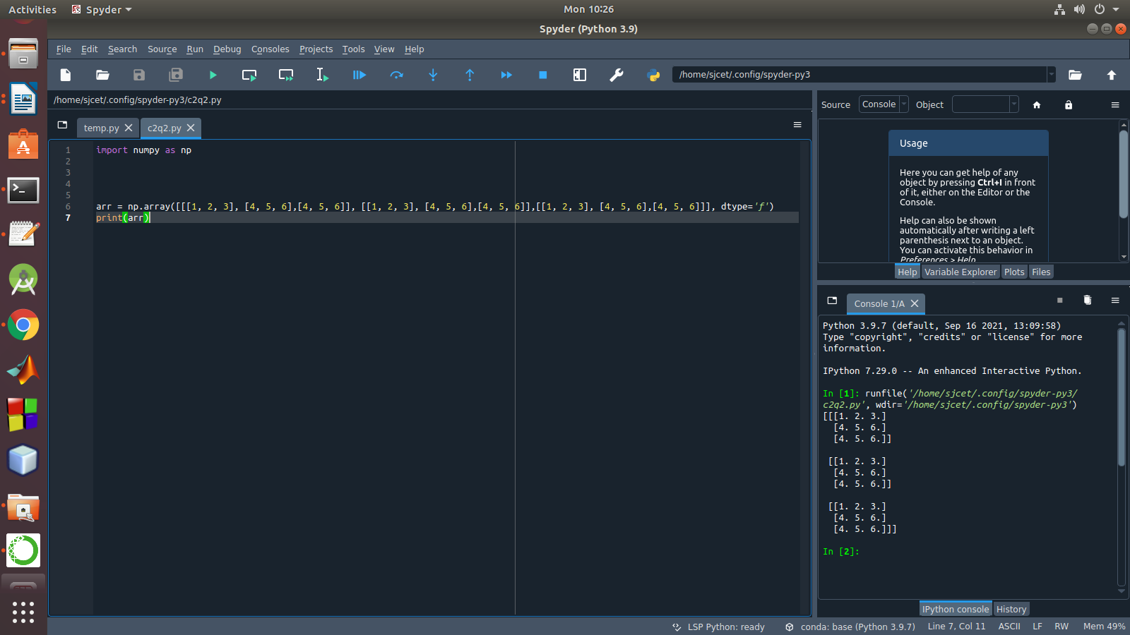

2. Create a 2 dimensional array (2X3) with elements belonging to complex data
type and print it. Also display
a. the no: of rows and columns
b. dimension of an array
c. reshape the same array to 3X2

PROGRAM

import numpy as np
x = np.array([[2, 4, 6], [6.5, 8, 10]])
print(type(x))
print(x)
numOfRows = np. size(x, 0)
print(numOfRows)
numOfColumns = np. size(x, 1)
print(numOfColumns)
print("No. of dimensions: ", x.ndim)
rs=np.reshape(x, (3, 2))
print(rs)
OUTPUT
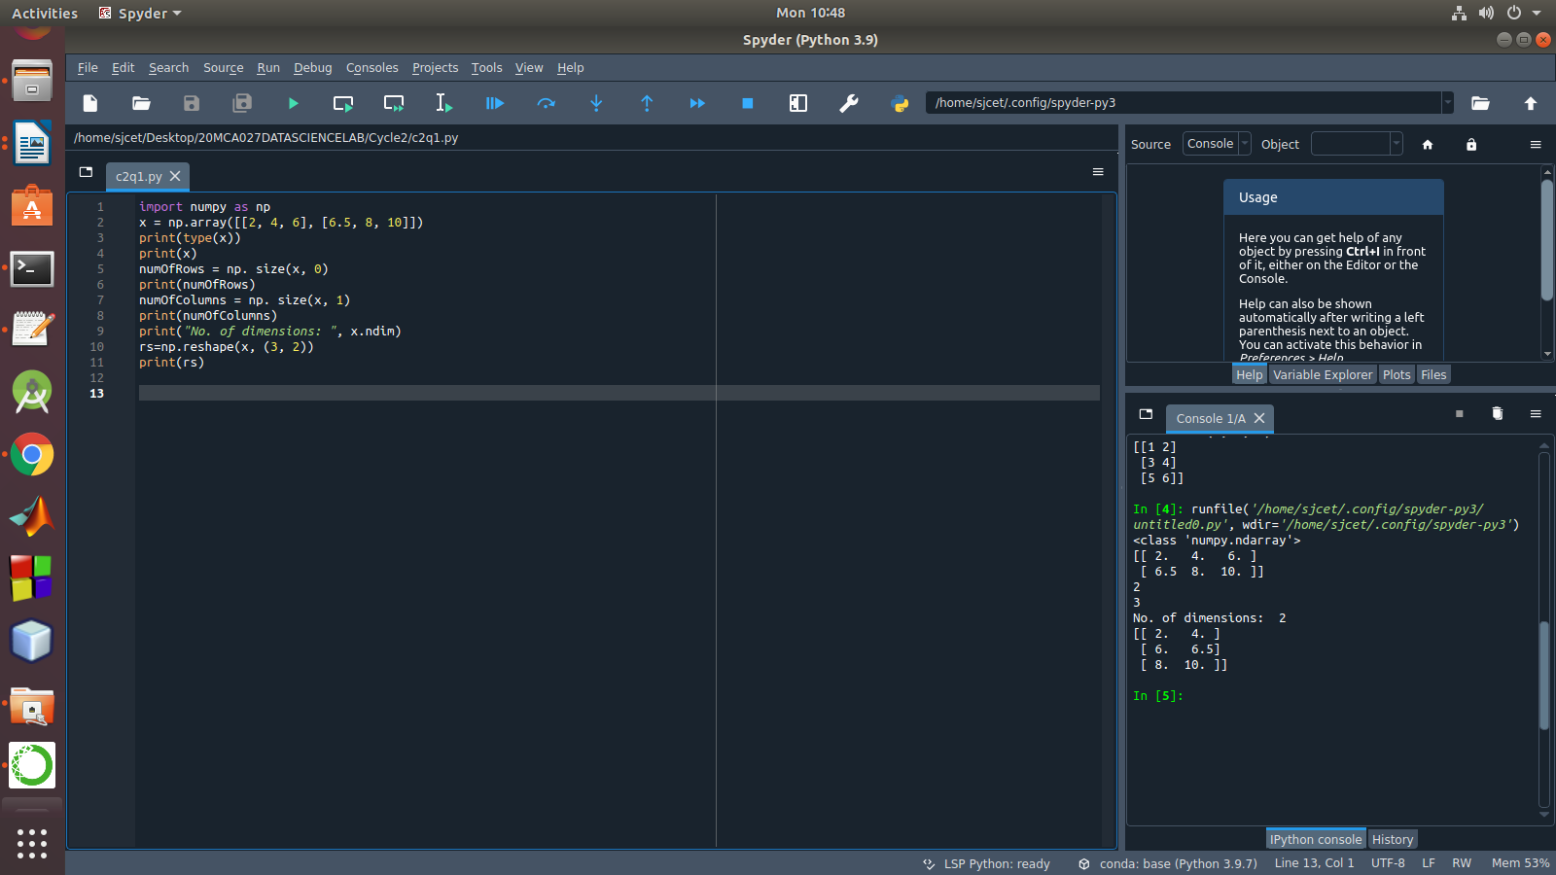

3. Familiarize with the functions to create
a) an uninitialized array
b) array with all elements as 1,
c) all elements as 0

PROGRAM

x = np.empty([2,2])
print("uninitialized array:",x)
y=np.full([2,2],1)
print("array with all elements as 1:",y)
z=np.full([2,2],0)
print("array with all elements as 0:",z)

OUTPUT

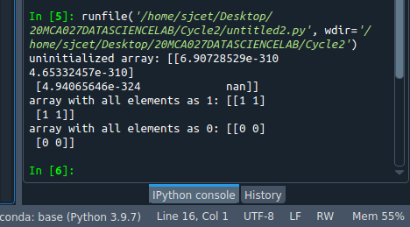

4.Create an one dimensional array using arange function containing 10 elements.
Display
a. First 4 elements
b. Last 6 elements
c. Elements from index 2 to 7

PROGRAM

import numpy as np
a=np.arange(1,11,1)
print(a)
a1=a[:4]
print("First 4 elements:",a1)
a2=a[6:]
print("Last 6 Elements:",a2)
a3=a[2:7]
print("Elements from index 2 to 7:",a3)

OUTPUT
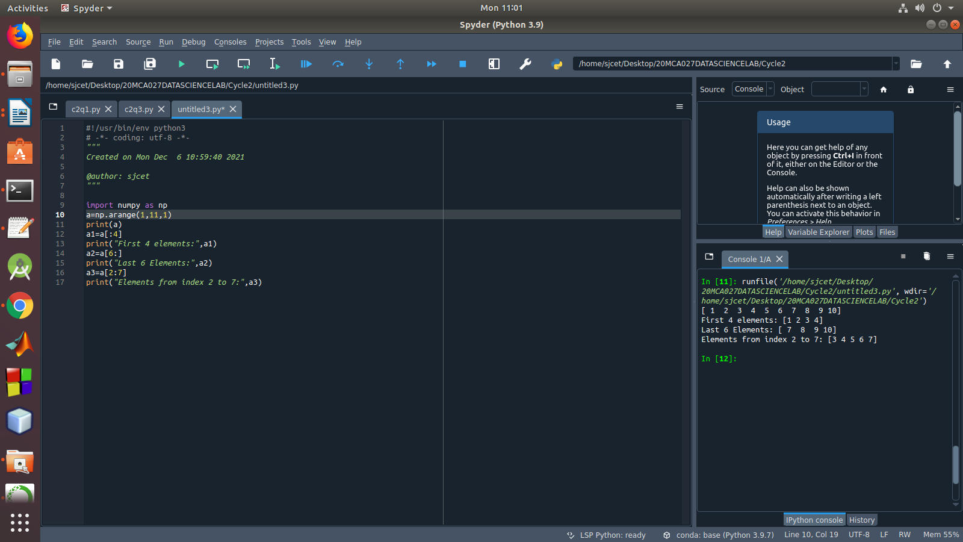

5. Create an 1D array with arange containing first 15 even numbers as elements
a. Elements from index 2 to 8 with step 2(also demonstrate the same
using slice function)
b. Last 3 elements of the array using negative index
c. Alternate elements of the array
d. Display the last 3 alternate elements

CODE

#!/usr/bin/env python3
# -*- coding: utf-8 -*-
"""
Created on Mon Dec 6 11:03:36 2021

@author: sjcet
"""

import numpy as np
a=np.arange(1,16,1)
print("Arange:",a[2:8])
arr=np.array([1,2,3,4,5,6,7,8,9,10,11,12,13,14,15])
print("Slicing:",arr[2:8])
print("Last 3 Elements:",a[-3:])
a1=a=np.arange(1,16,2)
print("Alternate Numbers:",a1)
print("Last 3 Alternate Numbers:",a1[-3:])

OUTPUT
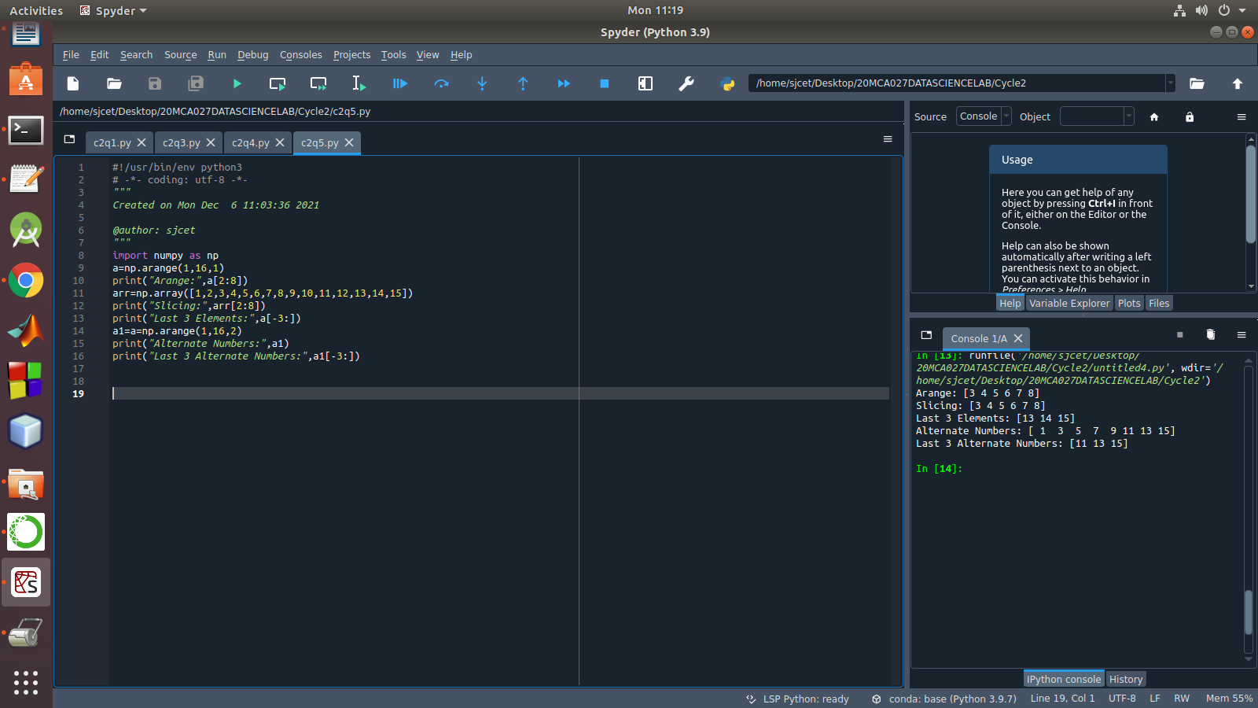

6. Create a 2 Dimensional array with 4 rows and 4 columns.
a. Display all elements excluding the first row
b. Display all elements excluding the last column
c. Display the elements of 1 st and 2 nd column in 2 nd and 3 rd row
d. Display the elements of 2 nd and 3 rd column
e. Display 2 nd and 3 rd element of 1 st row
f. Display the elements from indices 4 to 10 in descending order(use
–values)

PROGRAM

import numpy as np
a = np.array([[1, 2, 3,4], [4, 5, 6,5], [7, 8, 9,6], [10, 11, 12,7]])
print(a)
print("elements excluding the first row:\n",a[1:])
print("elements excluding the first Column:\n",a[:,:3])
print("elements of 2 nd and 3 rd column:\n",a[:,1:3])
print("2 nd and 3 rd element of 1 st row:",a[0,1],a[0,2])

OUTPUT
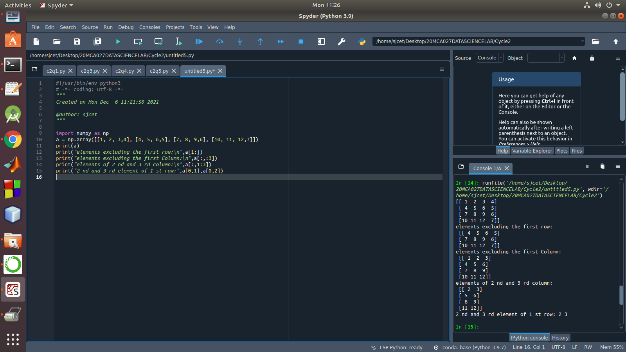

7. Create two 2D arrays using array object and
a. Add the 2 matrices and print it
b. Subtract 2 matrices
c. Multiply the individual elements of matrix
d. Divide the elements of the matrices
e. Perform matrix multiplication
f. Display transpose of the matrix
g. Sum of diagonal elements of a matrix

PROGRAM

import numpy as np
a = np.array([[1, 2, 3,4], [4, 5, 6,5], [7, 8, 9,6], [10, 11, 12,7]])
b = np.array([[1, 2, 3,4],[7, 8, 9,6] , [4, 5, 6,5], [10, 11, 12,7]])
print("Addition:\n",np.add(a,b))
print("Subtraction:\n",np.subtract(a,b))
print("Multiply the individual elements:\n",np.multiply(a,b))
print("Divide:\n",np.divide(a,b))
print("Multiply:\n",np.dot(a,b))
print("Transpose:\n",np.transpose(a))
print("Sum of Diagonal Elements:\n",np.trace(a))

OUTPUT

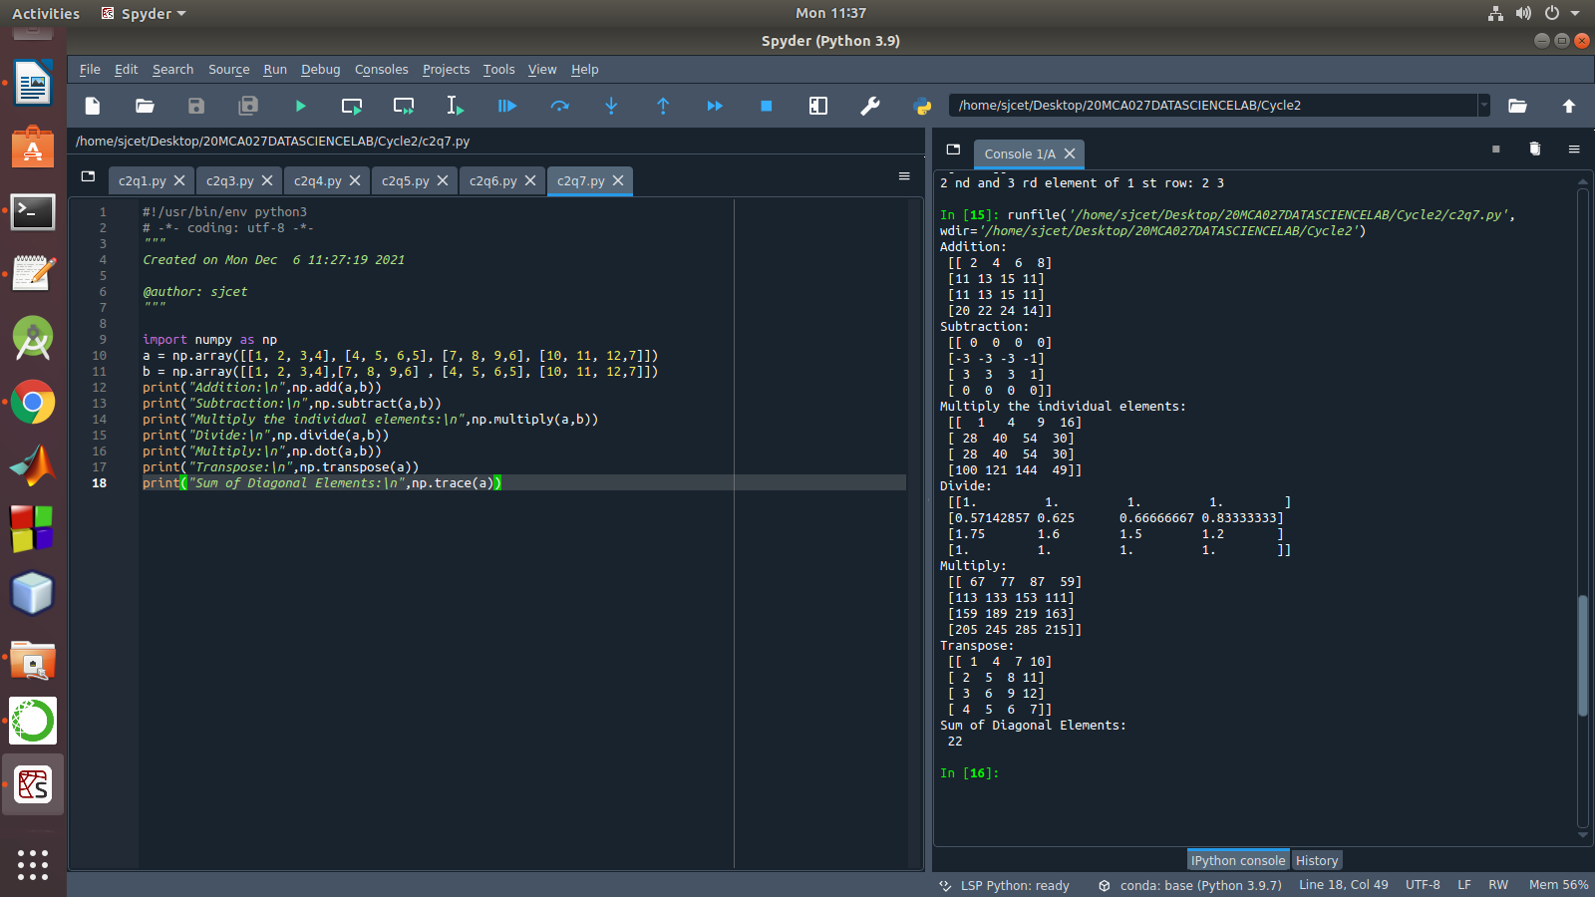

8. Demonstrate the use of insert() function in 1D and 2D array

PROGRAM

import numpy as np

arr1 = np.arange(10, 16)

print("1D ARRAY ")

print("The array is: ", arr1)

obj = 2

value = 40

arr = np.insert(arr1, obj, value, axis=None)

print("After inserting the new array is: ")

print(arr)

print("Shape of the new array is : ", np.shape(arr))

print("2D ARRAY ")

arr1 = np.array([(1, 2, 3), (4, 5, 6), (7, 8, 9), (50, 51, 52)])

print("The array is: ")

print(arr1)

print("The shape of the array is: ", np.shape(arr1))

a = np.insert(arr1, 1, [[50], [100], ], axis=0)

print("New array is : ")

print(a)

print("Shape of the array is: ", np.shape(a))

OUTPUT
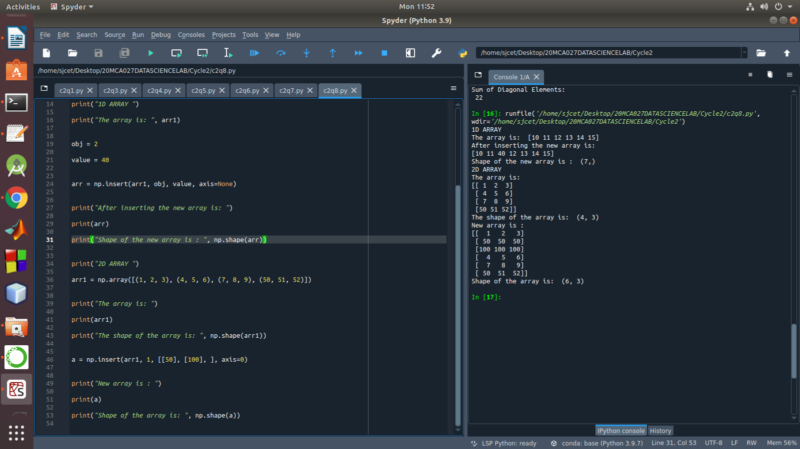

9.Demonstrate the use of diag() function in 1D and 2D array.

PROGRAM

import numpy as np

a= np.array([[3, 6,7,8],[10,11,12,13]])

b=np.array([[3, 6,8,7], [4, 2,1,0],[3,1,3,3],[1,1,2,2]])

x=np.diag(a)

y=np.diag(b)

print(x)

print(y)

OUTPUT

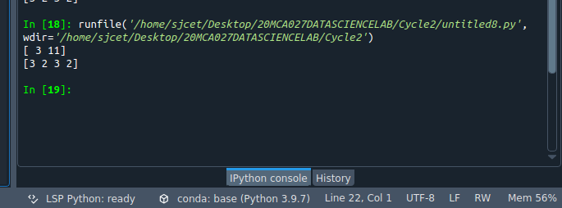
10.Demonstarte the use of append() function in 1D and 2D
array.

PROGRAM

"""
import numpy as np
a = np.array([[1,2,3],[4,5,6]])
b=np.array([1,2,3])
print("First array:")
print (a)
print("Second array")
print(b)
print ("\n")
print ("Append elements to array:")
print (np.append(a, [7,8,9]))
print (np.append(b, [7,8,9]))

OUTPUT

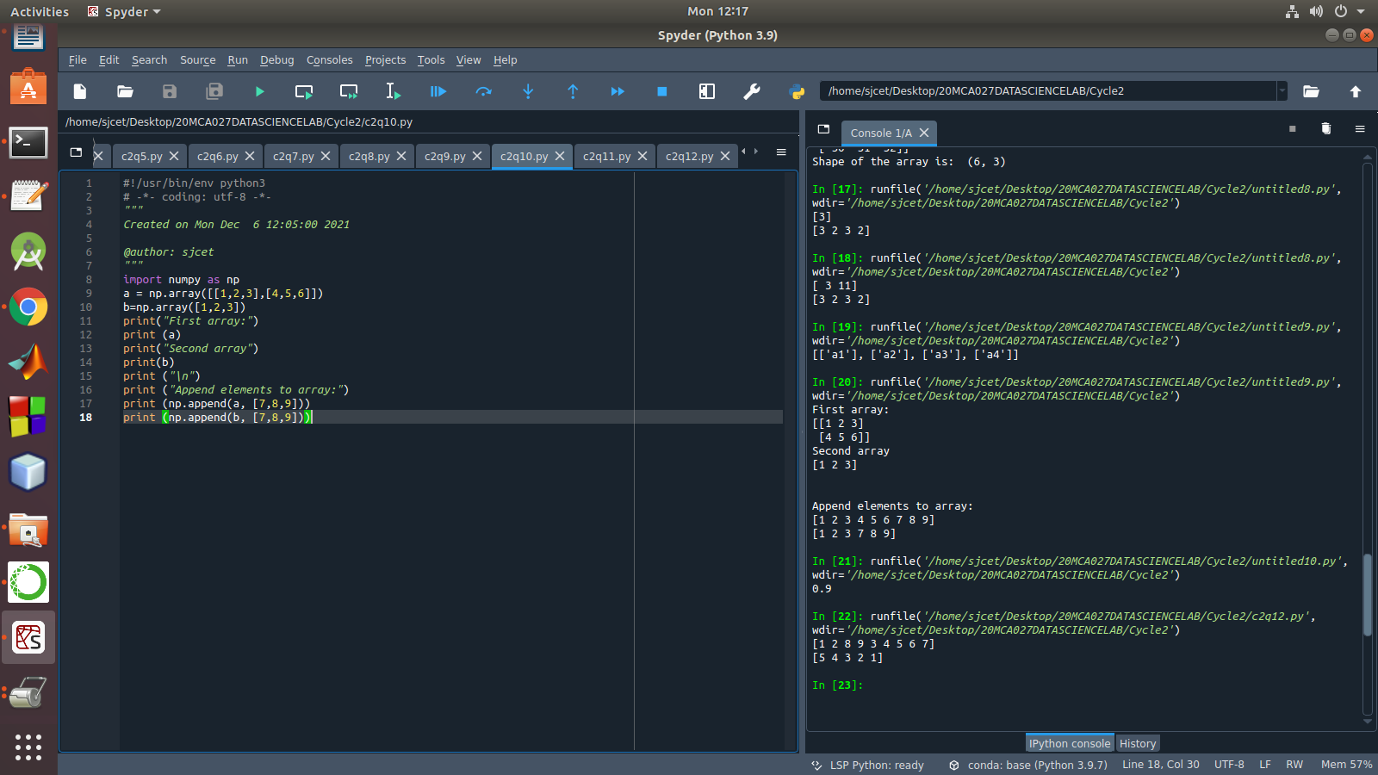

11.Demonstarte the use of sum() function in 1D and 2D array.

PROGRAM

import numpy as np
a=np.array([0.4,0.5])
b=np.sum(a)
print (b)

OUTPUT

12.Create a 1 Dimensional array

Display the elements from indices 4 to 10 in descending order(use
–values)

PROGRAM

import numpy as np

a = np.array([1,2,8,9,3,4,5,6,7])
print(a)
array_copy = np.sort(a)[::-1]
print(array_copy[4:10])

OUTPUT

